**CONCLUSION FOR SURVEY FOR TOURS & TRAVELS COMPANY:-**

First if we want to come to any conclusion we have to know that what and who have filled the information like how many were female or male, or percentage of people who live in India, etc….

* Forms response chart. Question title: Gender. Number of responses: 28 responses.

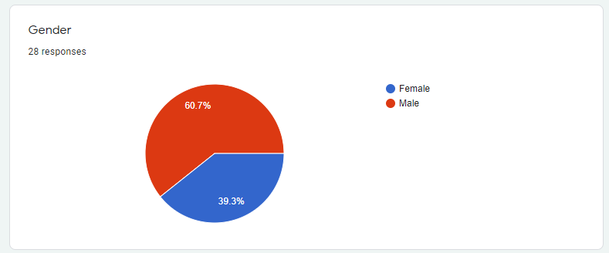

So after seeing among information you can see that from total of 28 people who have filled this form there are 60.7% are female, and 39.3% are male

* Forms response chart. Question title: Your favorite scenery to visit. Number of responses: 28 responses

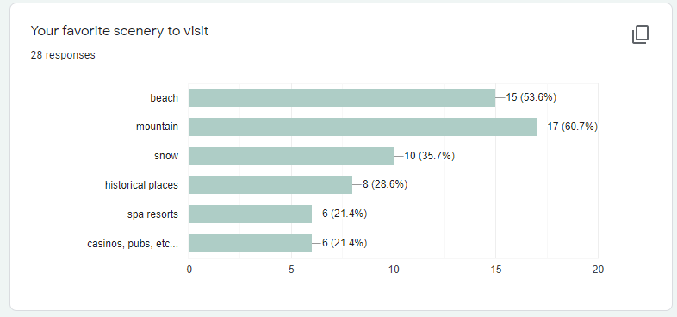

* Forms response chart. Question title: where would you like to go for holidays? Number of responses: 28 responses.

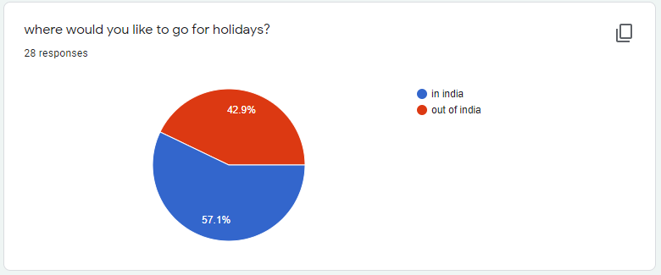

* Forms response chart. Question title: If in India, than where would you like to go?. Number of responses: 28 responses.

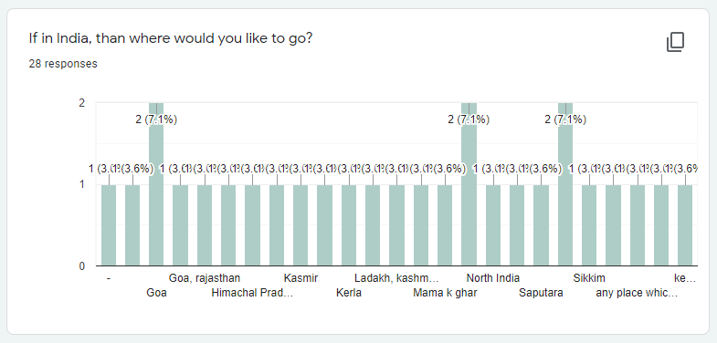

* Forms response chart. Question title: if out of India, than where would you like to go?. Number of responses: 28 responses.

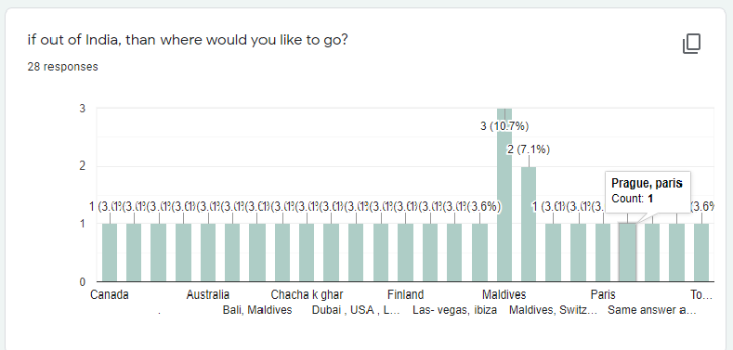

* Forms response chart. Question title: your preferred mode of transport? Number of responses: 28 responses.

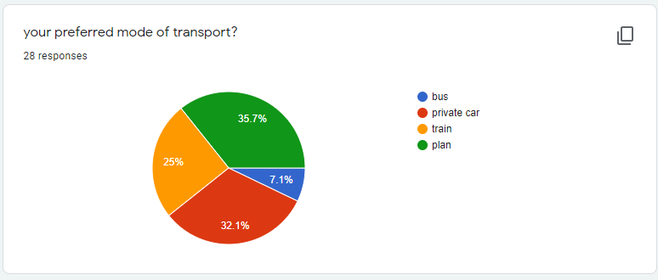

* So after seeing all the information and reading all the opinion of all the people who filled this form, you can say that if you want to open your own tours and travels company that you have to make sure that you have to make all the information about travel into the package, and also you have to make sure everything is clean. If the place that tour is trying, go to some adventure park or resorts than you have to make sure it is kids friendly. If some place that you are trying to go to some historical place or a mythical place than you have to make sure that it is old people friendly.